**CURRICULUM VITAE**

**Personal Details:**

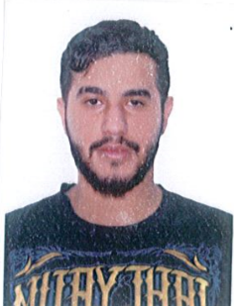**Name:** Jassim Mohammed Hassan Juma

**Address:** Bahrain, Madinat Hamad

House: 3183, Road: 1152, Block: 1211

**Date of Birth:** 15.01.1996

**Nationality:**  Bahraini

**Marital Status:** Single

**Phone Number:** 66356660

**E-mail:** [k.alsanady@gmail.com](mailto:k.alsanady@gmail.com)

**Education:**

Shaikh Abdullah bin Isa Al-khalifa industrial school (2011-2014)

**Languages:**

* **Arabic:** Mother tongue
* **English:** good in speaking and writing

**Skills:**

Excellent in working on a computer (Microsoft office).

Good and fast in doing mathematical calculations.